**Lab 9: Hyperparameter Grid Search**

**David Schulz**

1. Dataset
   1. The dataset I used for this lab is the premade one provided in the data directory, so I don’t know how exactly it was generated, but I am assuming flipping augmentation was used.
2. Part 1 – Interactive script



* 1. I successfully ran the Jupyter notebook and had it printed out as HTML.

1. Part 2 – Batch script interactively

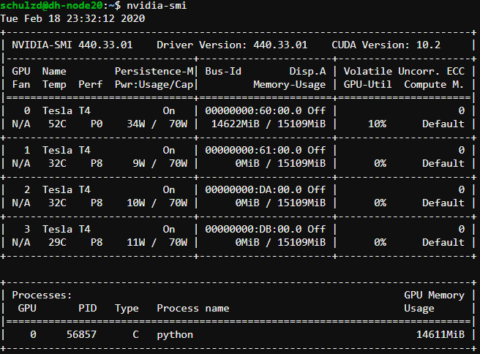

* 1. The image above is the screenshot of the result of the nvidia-smi call after starting the first experiment. 10% utilization was about the average.

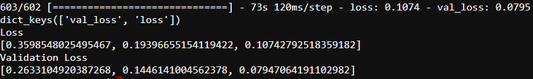

* 1. These were the resulting loss values of the first experiment in this part, running with a batch size of 32 and 3 epochs. As shown, the final validation loss got down to 0.0795.



* 1. These were the resulting loss values of the second experiment in this part, running with a batch size of 64 and 5 epochs. As shown, the final validation loss got down to 0.1173, an increase from the first experiment by 0.0378.

1. Part 3 – Batch script asynchronously

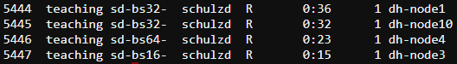

* 1. The image above shows all 4 jobs running in “batch” mode asynchronously.



* 1. Batch size: 32 Epochs: 5
  2. The final loss was about 0.0441. The hyperparameters were exactly what was provided on Blackboard, so this will be considered the “control” for this part. Compared to its 3-epoch counterpart in part 2, the loss decreased by about 0.035.



* 1. Batch size: 16 Epochs: 5
  2. The final loss was about 0.0235, a decrease of about 0.02 from the first job.

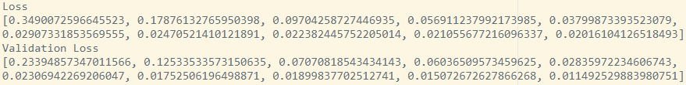

* 1. Batch size: 32 Epochs: 10
  2. The final loss was about 0.0115, a decrease of 0.0326 from the first job and about 0.012 from the second job.

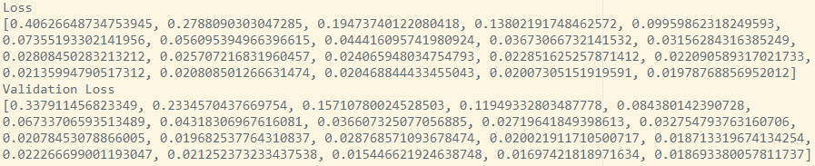

* 1. Batch size: 64 Epochs: 20
  2. The final loss was about 0.0187, a decrease of 0.0254 from the first job and 0.0048 from the second job, but an increase of 0.0072 from the third job.

1. Part 4 – Different models



* 1. The image above shows the two jobs using different models running at the same time.
  2. The first model I’m going to use is the one with the lowest loss value from part 3, the CommaAIModelPrime job with a batch size of 32 and 10 epochs.

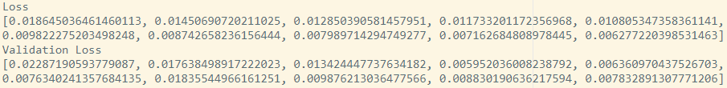

* 1. Model: NvidiaModel Batch size: 32 Epochs: 10
  2. The final loss was about 0.0078, a decrease of 0.0037 from the lowest loss value in part 3.

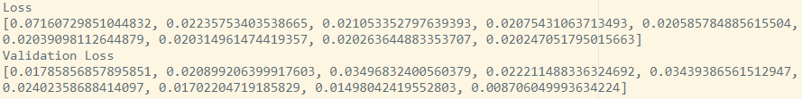

* 1. Model: NvidiaModelRegularization Batch size: 16 Epochs: 9
  2. The final loss was about 0.0087, an increase of 0.0009 from the nVidiaModel experiment. I used 9 instead of 10 because when I tried 10, it appeared to start overfitting because the validation loss spiked up after the last epoch.

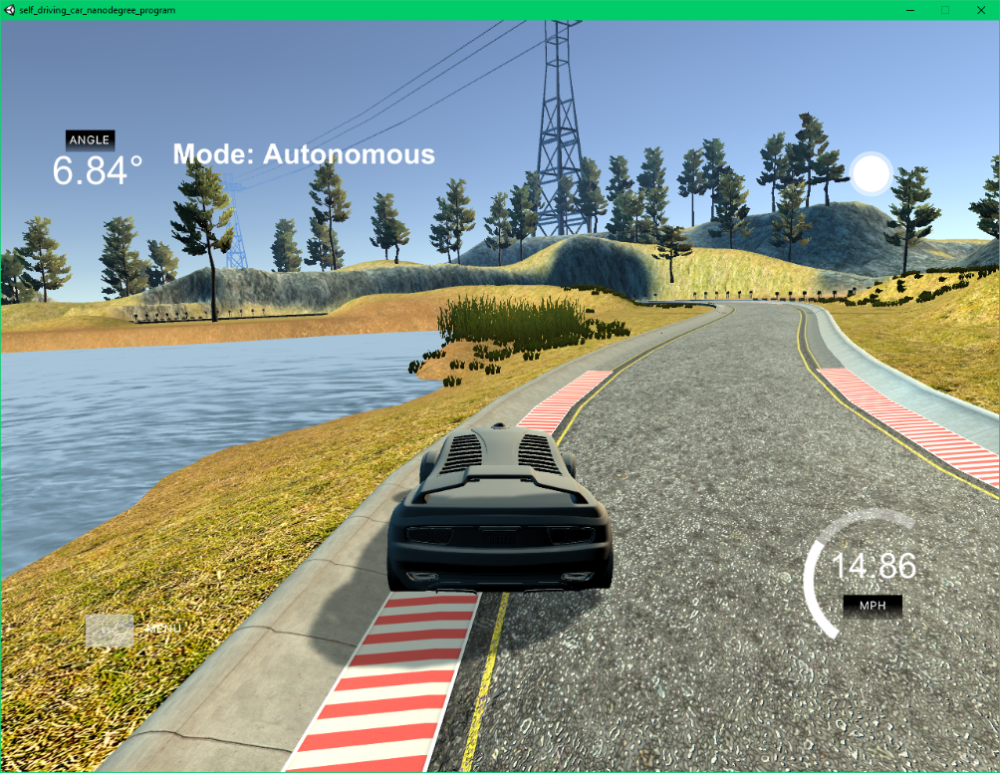

* 1. When testing track 1 with the CommaAI model, the image above shows the worst part of its autonomous movement, meaning it corrected itself enough right after that moment to get back into the middle of the track. That also means that the car never fell off of the track. There were a couple other close calls like this one, but none as close.

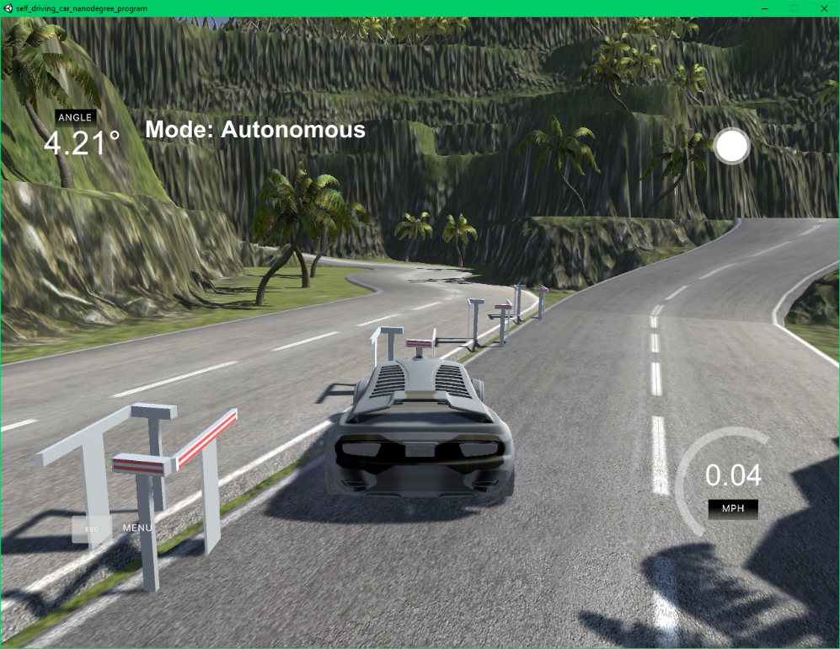

* 1. When testing track 2 with the CommaAI model, the image above shows the part of its autonomous movement when it stopped the car, which was very shortly after it began.

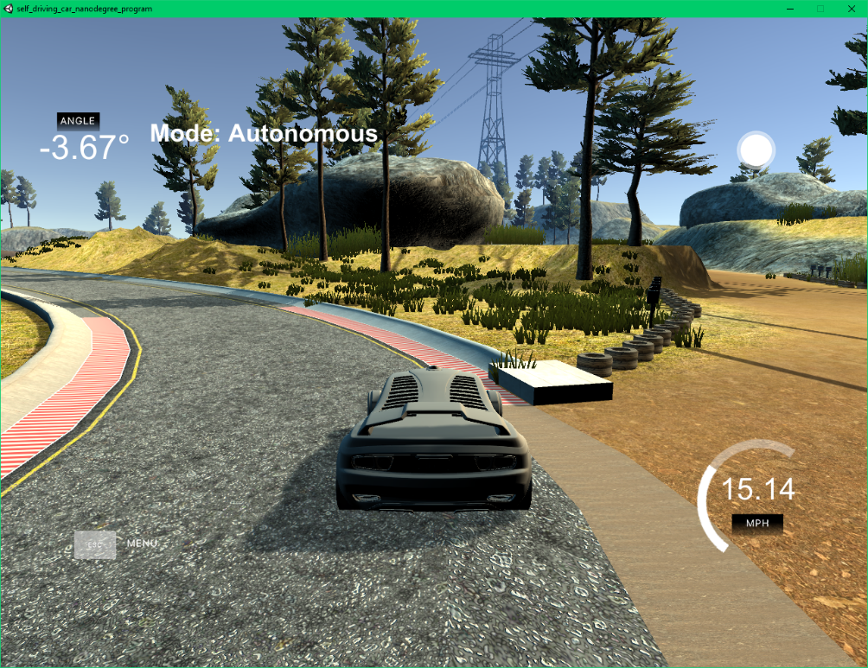

1. When testing track 1 with the Nvidia model, the image above shows the worst part of its autonomous movement, meaning it corrected itself enough right after that moment to get back into the middle of the track. That also means that the car never fell off of the track. Compared to the worst moment of track 1 with the CommaAI model, this is a great improvement because the car isn’t even on the curb. There also weren’t any other close calls.

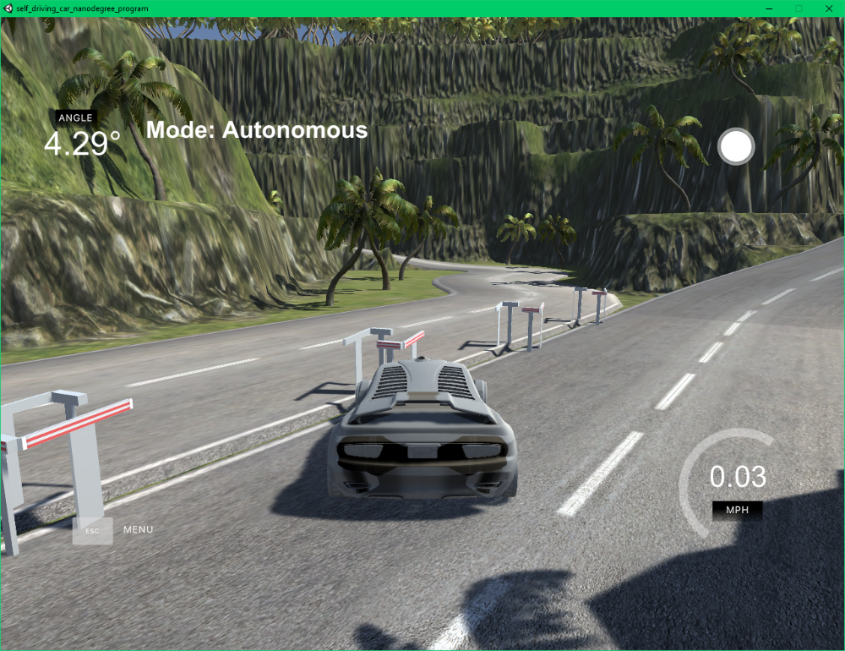

1. When testing track 2 with the Nvidia model, the image above shows the part of its autonomous movement when it stopped the car, which was very shortly after it began, exactly like the CommaAI model.

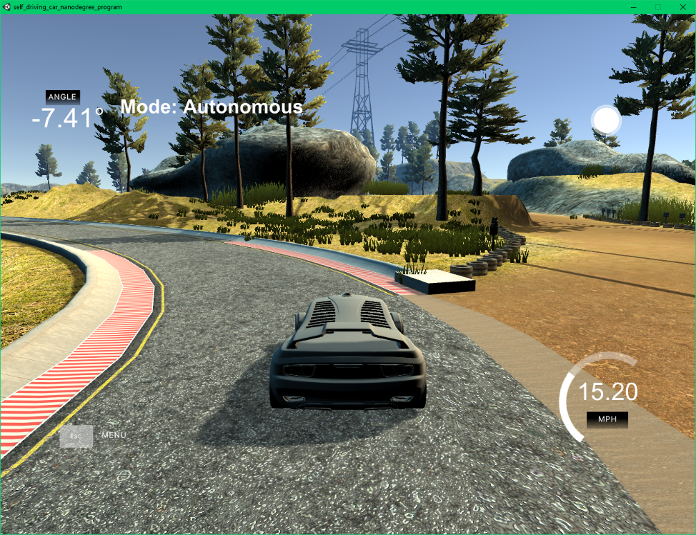

1. When testing track 1 with the NvidiaRegularization model, the image above shows the worst part of its autonomous movement, which isn’t very bad at all. That means that the car never got even close to falling off of the track. The turning was also by far the smoothest out of all 3 simulations.

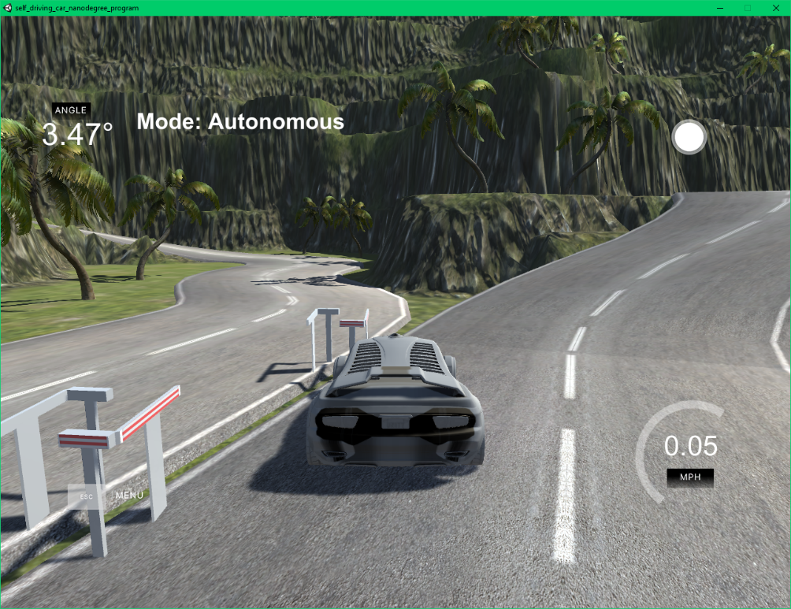

1. When testing track 2 with the NvidiaRegularization model, the image above shows the part of its autonomous movement when it stopped the car, which was very shortly after it began, but a little further than the first two simulations, as the car hit the last set of posts this time.
2. From these simulations’ results, the loss correlates to the quality of driving pretty well, as all did very well on the first track, not so well on the second, and had subtle improvements from the model with the highest loss to the model with the lowest loss.